

Faculty of Engineering

B.Eng. in Software Engineering

Microprocessor & Interfacing

Author: Thawanrat Atthawiwatkul Student ID:62011277

Author: Tinchupeam Weerayutvilai Student ID:62011281

Supervisors:

Dr. Kasin Vichienchom

Dr. NAPAT SRA-IUM

**Contents**

1. Introduction
2. System Overview
3. Hardware
4. Schematic Diagram & Block Diagram
5. Flowchart
6. Libraries
7. Codes
8. Improvements
9. Conclusion

Introduction

At this present time, the condition of the people's mindset about disposing trash is fairly sad. In fact, there are still many people who don't care about the environment. The condition of the garbage facility is lacking in terms of quality and quantity, and the mindset of the people who still consider the most practical waste disposal by letting it lie on the roadside or dumping it into the river.

Smart Trash Bin will solve the problem. Smart Bins help to create a cleaner, safer, more hygienic environment and enhanced operational efficiency while reducing management costs, resources, and road-side emissions.

System Overview

The research on smart trash bin models consists of using Internet of Things (IoT) technology and ultrasonic sensor to measure the level of trash in percentage which will tell when it is full on the LCD screen.

Hardware

* LPCXpresso LPC1769
* LCD screen
* Ultrasonic sensor HC-SR04
* Bread board

Schematic Diagram & Block Diagram

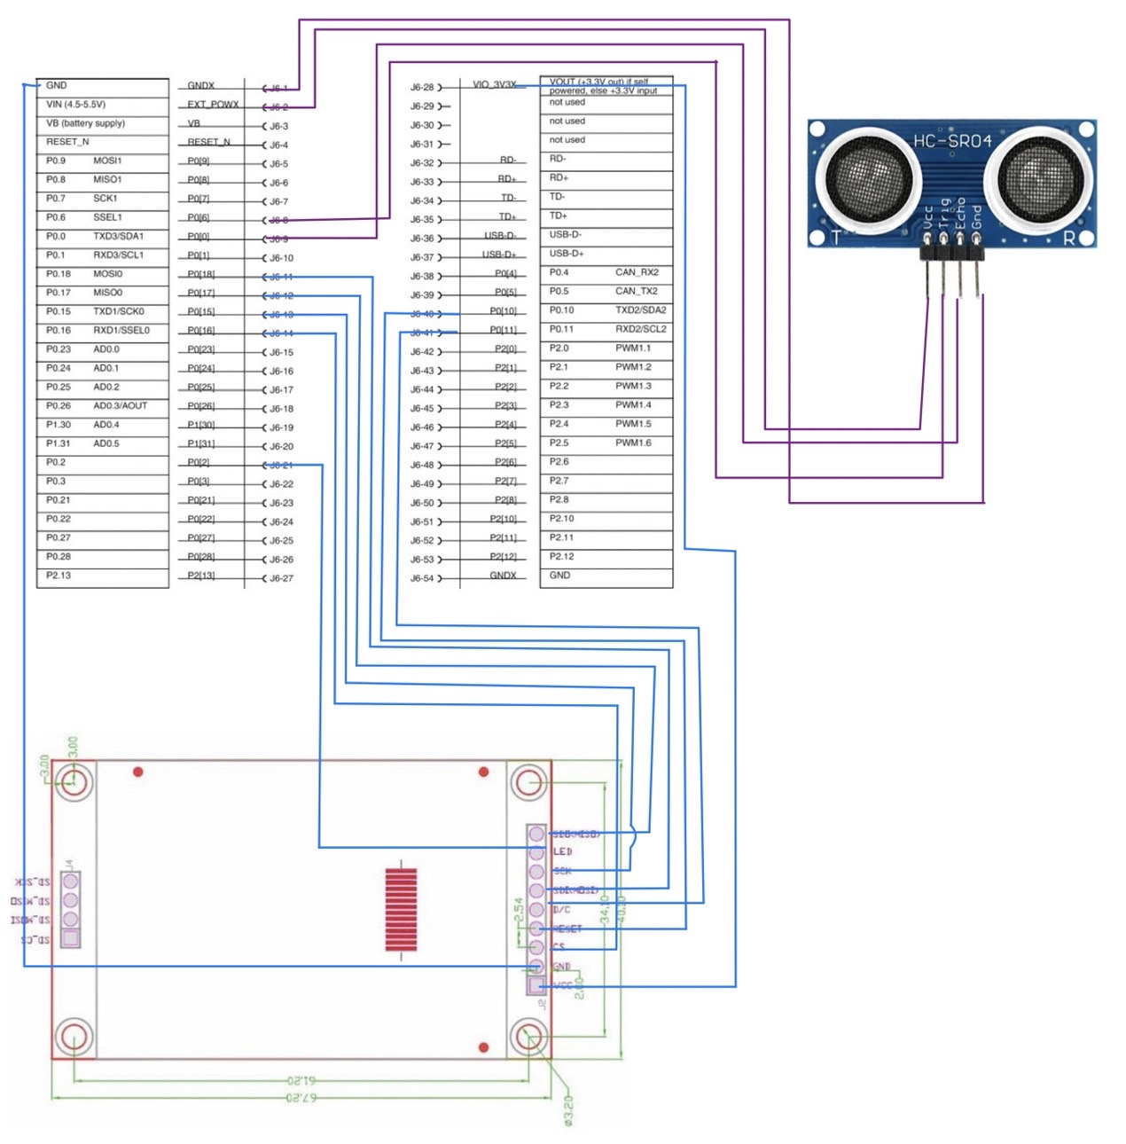

Flowchart

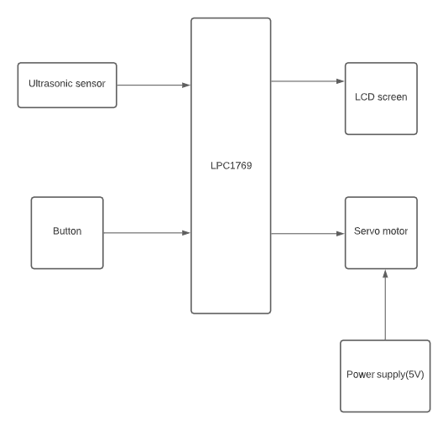

Libraries

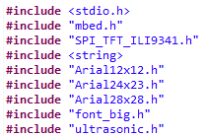

Code

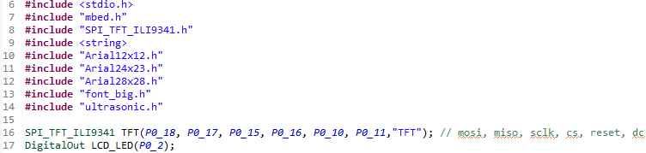

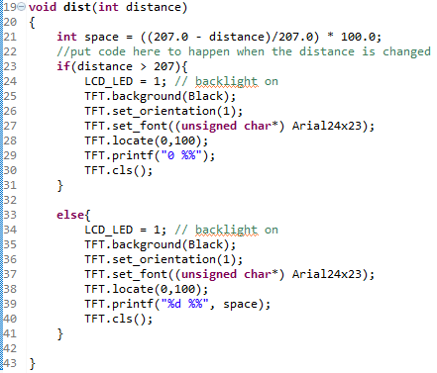

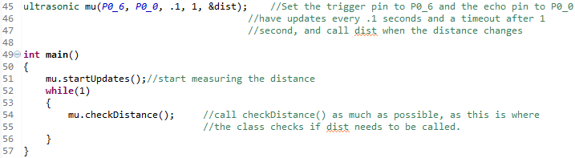

Improvement

We will make the bin door open automatically when the ultrasonic sensor can detect someone nearby using servo motor to power the servo leg to open the bin’s door.

Conclusion

The project uses the knowledge we have learnt from the lecture and lab. We also get to work in a team and create new useful things. We also experience many errors during work but eventually we find the right solution on time.